**APPLICATION DEVELOPMENT FOR FINDING FLATMATES**

**SOCIAL MEDIA OUTREACH STRATEGY:**



**Social media is all about connecting – you send friend requests, follow people, share ideas, and create partnerships. With such a huge networking potential, you can’t help but wonder how you can leverage social media outreach to increase your**[**sales and build your brand**](https://hyperise.com/blog/sales-automation/)**.**

**On paper, social media**[**outreach seems simple enough**](https://hyperise.com/compare/outreach-vs-salesloft)**: you roll up your sleeves and start reaching out to people from your industry. With enough time and effort, you’re bound to get some results, right?**

**While that might be true, there are much easier ways to get great results by working smarter, not harder. These techniques include doing your research, segmenting your audiences, and preparing your outreach campaign long before you send out the first message, email, or connection request.**

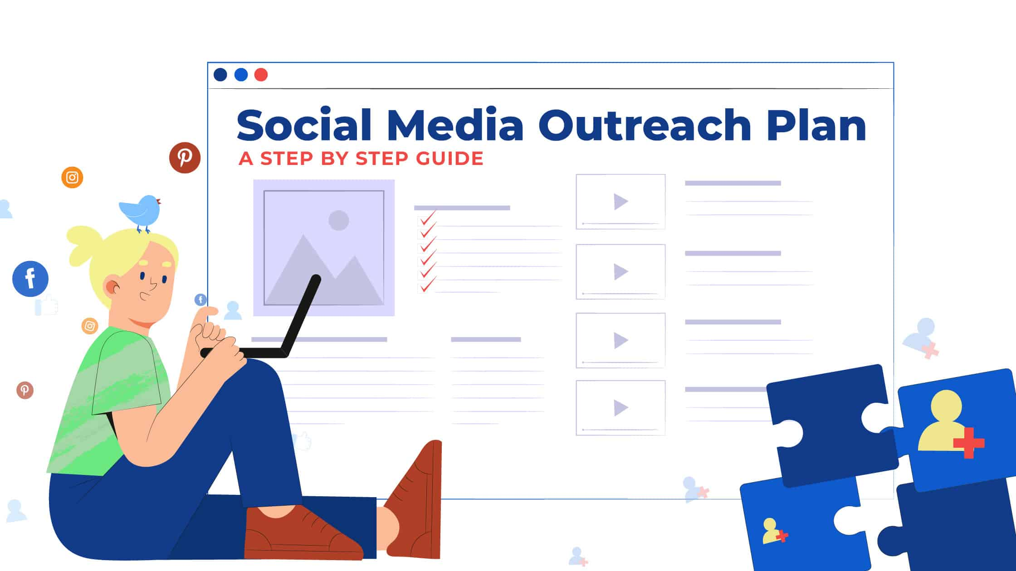

**THE ULTIMATE GUIDE TO SOCIAL MEDIA OUTREACH:**

**Step 1: Optimize your online presence:**

**Before you can even think about sending outreach messages, you need to take care of your social media profiles.**

**A bad profile can undermine the smartest outreach messages and the most researched target audiences. Your profile is the first thing your prospects will see, which is why you need to spend some time to make sure your prospects feel like you’re a trustworthy professional who knows what they’re talking about.**

**Here are a few things you need to do:**

* **Profile photo – whether you’re using LinkedIn, Twitter, Facebook, or any other network for outreach, you need to use the right profile photo. Your face should take up most of the photo, you should be dressed professionally, and make sure you’re smiling! Try to look honest and authentic, not like someone just downloaded a stock photo of a business person.**
* **Headline/Bio – all your social media profiles have to display your expertise in a clear, concise way. Avoid buzzwords like “social media marketing wizard” and “spirited individual” – they’re overused and they don’t say anything meaningful. Try to include some relevant keywords that can illustrate what you do in simple words.**
* **Summary – this is specific to LinkedIn. The summary section gives you a great opportunity to tell us a little bit more about your previous experience and your best results so far. Use this field to share some of your most successful business cases and remember – use keywords! They will help you show up when people search for services like yours on LinkedIn.**

**Step 2: Build an image in the industry:**

**Once you’re content with your profiles, it’s time to put them to use!**

**Stay active and engage in industry conversations to build an image in your industry. This will contribute to the overall quality of your profiles, as your profile visitors will see how knowledgeable you are about industry topics.**

**You can do this by posting quality content – new insights, case studies, and research results from the industry are always good conversation starters. You can preface each of those with your opinion on the topic and encourage engagement. Posting on**[**Wednesday and Thursday mornings**](https://sproutsocial.com/insights/best-times-to-post-on-social-media/#li-times)**may work best on LinkedIn, so keep that in mind!**

**Another easy way to get your name out there is by joining groups. LinkedIn and Facebook have thousands of groups for all kinds of industries, in which professionals discuss relevant topics all the time.**

**Step 3: Collect quality leads:**

**We can say that the first two steps were all about improving your profile and your industry status. That’s an ongoing process that you should always be working on. But, once you’ve set up the basics, that’s when the real work begins.**

**The first part of the “real work” is collecting leads.**

**The key thing with collecting leads is quality. You want to focus on the people that are highly likely to be interested in your offer, instead of taking a “paint by numbers” approach and try to grow your list at all costs. Get creative and search for people in your industry that are as close to your target audience persona as possible.**

**Below are a few ways to do this:**

**1. TARGET BY INTERACTION:**

**You can find a viral LinkedIn post from your industry and scrape all the people who have interacted with it. That way, you’re getting a solid list of people who follow news from your industry and are actively engaged in discussions.**

**2. SCRAPE GROUPS:**

**Remember the LinkedIn and Facebook groups we mentioned? Not only are they useful as potential networking opportunities, but you can also scrape them and get the profiles of all the members.**

**Note that some groups can have more than 10.000 members, so it may be worth checking out their profiles and making sure which members are worth connecting with. Some people in groups can be recruiters or students of the craft rather than people truly interested in what you have to offer.**

**3. LINKEDIN ADVANCED SEARCH:**

**Finally, LinkedIn has an elaborate search that enables you to narrow down your results to a great extent. You can optimize for location, college history, previous and current employers, and job title, among other things.**

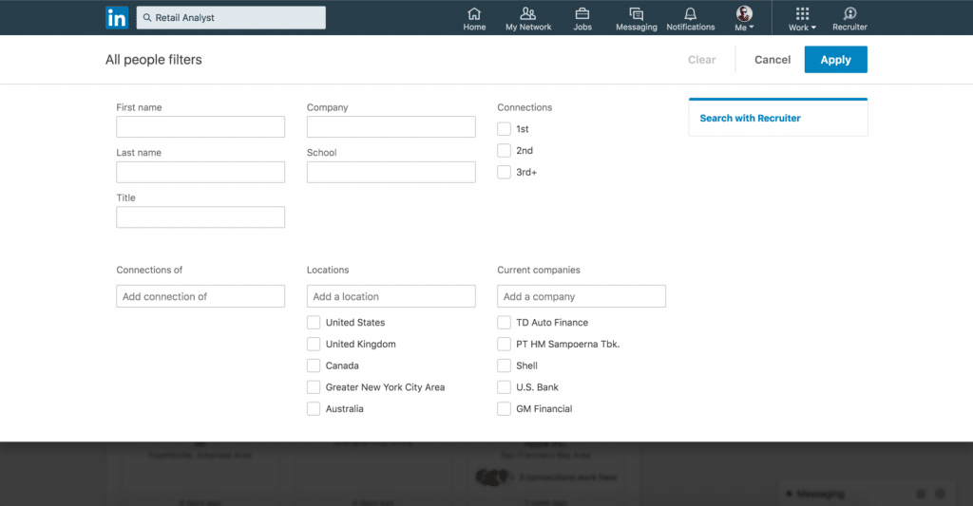

**So, enter as many criteria as you can and you’ll get a list of specific leads that are all worth contacting.**

**Step 4: Personalize your outreach strategy:**

**Now it’s finally time to deal with those outreach messages.**

**You can contact your leads via LinkedIn or email. Even if you found them on Facebook or Twitter, we don’t recommend getting in touch on these networks, as they can be too personal and unprofessional. Instead, you can use a tool like**[**Hunter.io**](https://hunter.io/)**, get their emails, and send them a well-designed, personalized email.**

**Personalizing your outreach campaign isn’t hard but it takes time and effort on your part. You need to approach every lead on a micro level and think about how you can get through to them and grab their attention. What do you have in common? Where did you get their contact? What can you offer that’s valuable to them specifically?**

**All of these are important questions that can help you create a personal message tailored to each person on your lead list.**

**With**[**Hyperise**](https://hyperise.com/)**, you can add an image to your message and integrate with the TexAu tool to send highly personalized messages to each one of your prospects. Once you create an image, an integration with TexAu will add your prospect’s name wherever you want on the image. Whether or not they’re interested in your offer, this approach will surely get their attention.**

**Step 5: Analyse, optimize, and improve:**

**Finally, one of the best ideas when it comes to prospecting is to keep tracking your results and see what works.**

**A great way to do this is by segmenting your leads. For example, you can go through your list of 500+ leads and highlight all the decision-makers. Group them and track the results for that group vs. other groups that you set up: interns, 2nd LinkedIn connections, etc.**

**Depending on your product, you’ll find that some groups perform better than others. Focus your attention on those groups and don’t waste as much time on the ones that don’t perform.**

**As for how you can measure that performance, most prospecting tools offer elaborate analytics packages. These can show you important stats like open rates, click through rates, and bounce rates – all of which are good indicators of your campaign’s success.**

**Social media outreach: conclusion**

**As you can see, an outreach campaign starts way before you start typing actual messages.**

**Think of it this way: you want to put yourself in a position where sending a message is almost a formality. You need to be confident in your lead lists and the research that led up to them.**

**Then you can start creating good messages. If you need any help to improve your outreach results and take personalization to the next level, try out**[**Hyperise**](https://hyperise.com/)**. With it, you’ll be able to add a new dimension to your outreach strategy and experiment with different personalization**

**REPORT CREATED BY**

**FAHAD IQBAL SHAH**

**PRODUCT MANAGEMENT INTERN**

**NOVO CABS**